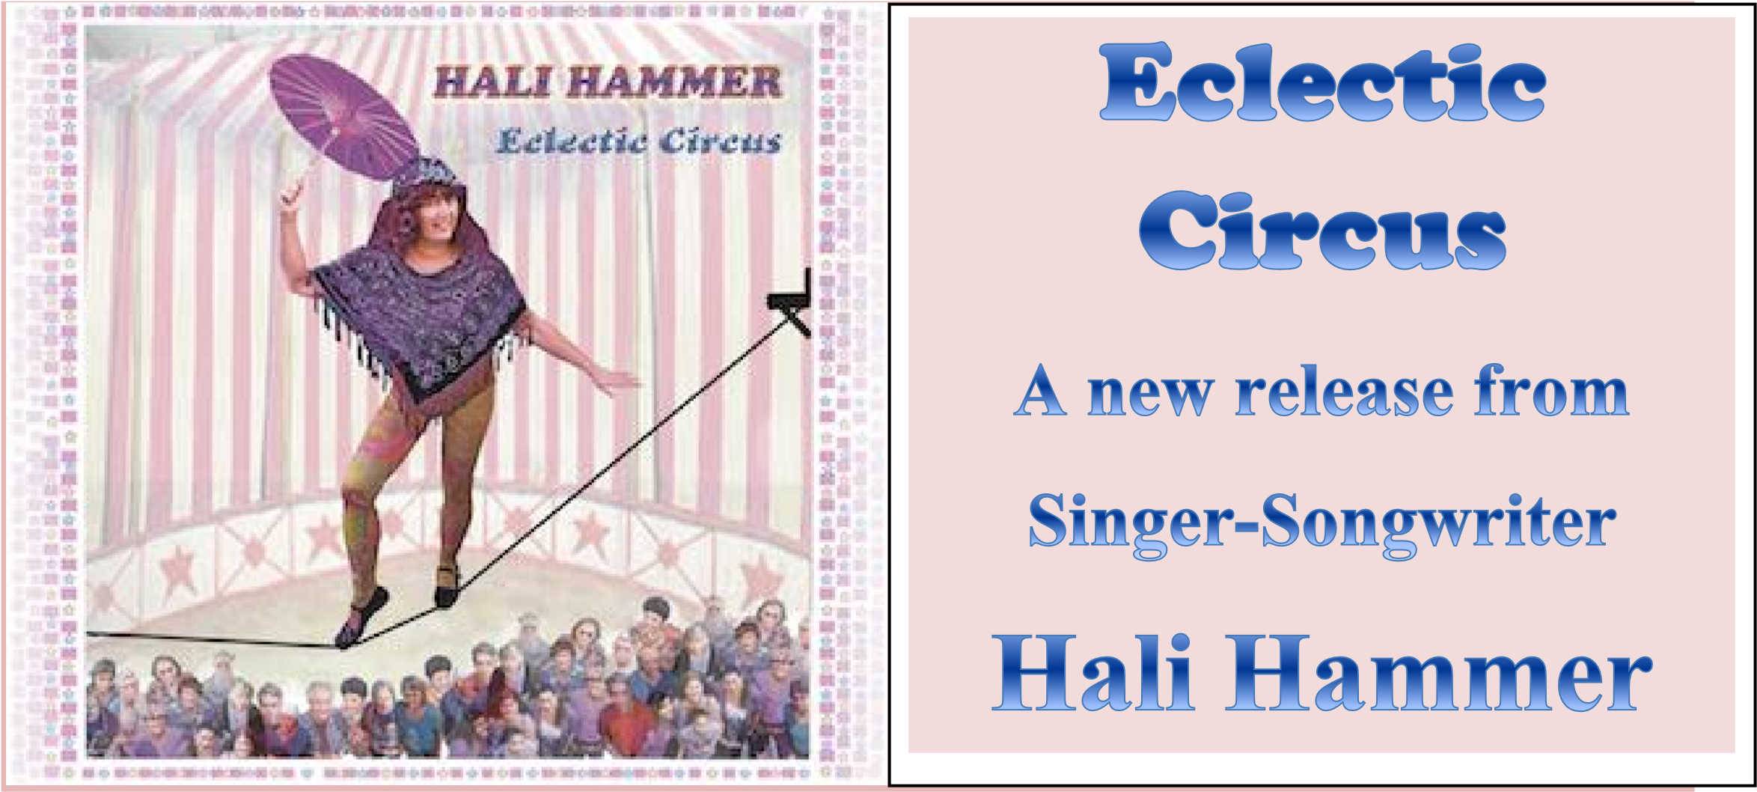
In Eclectic Circus, Hali Hammer presents a wide variety of songs and themes in an Americana style. Whether the subject matter is serious or humorous, Hali retains an optimistic approach to life that leaves the listener with a hopeful message. The songs range from a capella Redwood to full band arrangements of In a World Gone Mad and Will I Dream. The selections encompass Hali’s extensive range of life experience. They mesmerize the listening audience with story songs that reflect her views of the world and hopes for the planet, tales of family and friends, reflections of events that shaped her life, love songs, and some numbers that are just plain fun.
Eclectic Circus is enhanced by a host of talented musicians and singers, including the guitar wizardry of Randy Berge, Paul Herzoff on harmonica, and other gifted Bay Area musical artists featured on many of the selections (see back of this sheet for more information on the individual songs).
Hali Hammer is an award winning singer-songwriter with a vast array of musical experience in varied styles and settings. Hali joined her first band in 1968 while attending Queens College in NY, and went on to perform with other musicians and as a solo act. In 1981 she initiated and co-produced the Save the Mountain compilation album to protect Lake Minnewaska from development. It is now a NY State Park.

Moving to the Bay Area from her native New York, Hali joined Freedom Song Network in 1985 and was a member of the chorus that sang onstage behind Nelson Mandela at the Oakland Coliseum. Her song Bottom of the Ninth was aired on KNBR-San Francisco preceding the first game of the 1989 Bay Bridge
World Series. She is VP of the San Francisco Folk Music Club and was the coordinator of the 2003 Berkeley Free Folk Festival. Hali created and produced the Sing Out for Earth Day video montage of 33 groups across the nation singing This Land Is Your Land on April 22, 2012, which debuted at a screening in SF on the 100th anniversary of Woody Guthrie’s birthday. She has produced two YouTube videos for Save the Berkeley Post Office in conjunction with the East Bay Media Center. She currently worked with Country Joe McDonald to organize the “Berkeley Protest Fest”, which was held at the Berkeley Unitarian Fellowship on August 15th. She has been listed in Who’s Who of American Women.
Hali also has three other CDs: “I Refuse To Believe”, “Gypsy-O”, and “The Best of Hali Hammer”.
Eclectic Circus is available through the website (www.halihammer.com) or on CD Baby (CDBaby.com).
Contact Hali at halih@halihammer.com.

